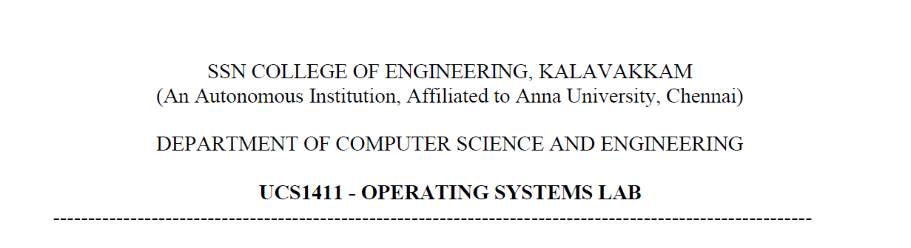

**NETWORKS LAB**

**EXERCISE 2**

Name: Jayannthan P T

Dept: CSE ‘A’

Roll No.: 205001049

**Aim:**

To transfer a file from server to client using TCP socket programming.

**Algorithm:**

**CLIENT**

1. Create a socket using socket() system call.

2. Connect it to the server.

3. Prompt the user to enter the file name.

4. Transfer the file name to the server

5. Receive the contents of the file and save in a new location

6. Close the socket

**SERVER**

1. Create a socket using socket() system call.

2. Bind the created socket with the port.

3. Listen for the connections.

4. When the server receives file name from the client, read the contents and send the contents to client.

**Code:**

**Server**

#include <netinet/in.h> *//structure for storing address information*

#include <stdio.h>

#include <stdlib.h>

#include <sys/socket.h>

#include <string.h>

#include <sys/types.h>

#include <unistd.h>

#include<fcntl.h>

**int** main(**int** argc, **char** **const**\* argv**[]**)

{

**int** port=atoi(argv[1]);

**int** serSockID = socket(AF_INET, SOCK_STREAM, 0);

**char** fileText[255],filename[100];

**struct** sockaddr_in servAddr;

    servAddr.sin_family = AF_INET;

    servAddr.sin_port = htons(port);

    servAddr.sin_addr.s_addr = INADDR_ANY;

    bind(serSockID, (**struct** sockaddr*)&servAddr,sizeof(servAddr));

    listen(serSockID, 1);

**int** clientSocket = accept(serSockID, NULL, NULL);

    printf("\nConnected\n");

**int** connected=1;

*/*while(connected)*

*{*/*

        read(clientSocket,filename,sizeof(filename));

**int** fd=open(filename,O_RDONLY);

        read(fd, fileText, sizeof(fileText));

        printf("File Path Recieved: %s\nMessage read:%s\n!!!Sending the file to client!!!\n\n",filename,fileText);

        send(clientSocket, fileText, sizeof(fileText), 0);

*/*if(strcmp(serMsg,"exit")==0)*

*{*

*connected =0;*

*}*/*

*//}*

    return 0;

}

**Client**

#include <netinet/in.h> *//structure for storing address information*

#include <stdio.h>

#include <stdlib.h>

#include <sys/socket.h>

#include <string.h>

#include <sys/types.h>

#include <unistd.h>

#include<fcntl.h>

**int** main(**int** argc, **char** **const**\* argv**[]**)

{

**int** port=atoi(argv[1]);

**int** sockD = socket(AF_INET, SOCK_STREAM, 0);

**struct** sockaddr_in servAddr;

    servAddr.sin_family = AF_INET;

    servAddr.sin_port= htons(port);

    servAddr.sin_addr.s_addr = INADDR_ANY;

**int** connectStatus= connect(sockD, (**struct** sockaddr*)&servAddr,sizeof(servAddr));

*//printf("\nConnected\n");*

    if (connectStatus == -1) {

        printf("Error...\n");

    }

    else

    {

**int** connected=1;

**char** fileText[255],filename[100];

*/*while(connected)*

*{*/*

            printf("\nEnter filepath in server:");

            scanf(" %s",filename);

**int** fd=open(filename,O_RDONLY);

            read(fd, fileText, sizeof(fileText));

            printf("\n%s",fileText);

**int** wr=write(sockD,filename,sizeof(filename));

            printf("\nFilename sent to server\nWaiting for response...\n");

            recv(sockD, fileText, sizeof(fileText), 0);

            printf("Message: %s\n", fileText);

*/*if(strcmp(strData,"exit")==0)*

*{*

*connected =0;*

*}*/*

*//  }*

    }

    return 0;

}

**Output:**

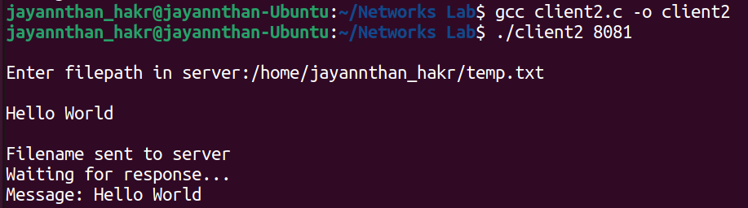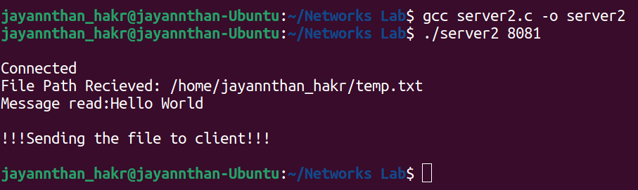

**Learning outcome:**

Learnt to create connection using sockets

Learnt to communicate between server and client using socket